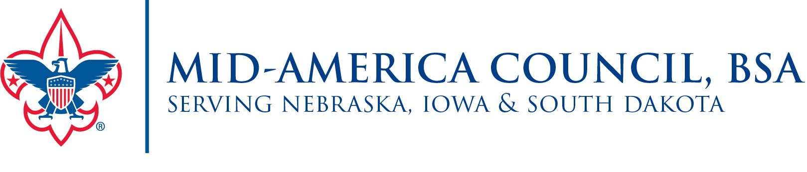

2023 Popcorn Dates to Remember
(Subject to Change)
Sale Dates
July 1 Online sales begin
September 8 Sale Begins
Sign-Up/Trainings
June 30 Popcorn commitments are due
July/August Popcorn Training
Pre-Order (Show and Sell) Deadlines
August 23 Unit Initial Order due at noon in Trail’s End Popcorn System
August 23 Home Delivery Sign Up (Metro Only)
September 6-7 Metro Home Deliveries
September 6-7 Initial Order Distribution Dates
Replenishment Dates: Orders due Sunday Night at 7PM
September 14 Metro Warehouse (Order Due Sept. 10)
September 21 Metro Warehouse (Order Due Sept. 17)
September 28 Metro Warehouse (Order Due Sept. 24)
October 5 Metro Warehouse (Order Due Oct. 1)
October 3 GR, DD, TC, OH – Before Roundtable (Orders due Oct. 1)
October 5 TL, PLS, WE, TB East – Before Roundtable (Orders due Oct. 1)
October 12 Durham Scout Center (Order Due Oct. 8)
Amnesty Day: (All Amnesty Product due in System by 10/1 at 7PM)
October 2 Metro Amnesty Day (IH, BH, WW & TB)
October 3 GR, DD, TC, OH – Before Roundtable
October 5 TL, PLS, WE, TB East – Before Roundtable
Final Order/Return Deadlines
October 30 Unit to Unit transfers must be marked as completed in system by 11:59PM
October 30 All returns due in the system by 11:59PM
October 30 Unit Final Order due in popcorn system by 11:59PM
October 29-31 Metro returns due at Council Office (sign up will be sent out)
November 2 TL, PLS, WE, TB East Returns– Before Roundtable
November 7 GR, DD, TC, OH Returns– Before Roundtable
*Please be prepared to take all of your final order at returns
November 15-17 Final Popcorn delivered product to districts

Unit Payment: All popcorn payment is due November 20th
Return Policy: Return maximum of 10% and in full cases. Cases can be previously opened but need to be a full case of same product when returned. No chocolate returns are permitted.

