**2020 Camp Card Scout Incentives**

The Camp Card program is designed to help Scouts earn their way to camp. On top of selling the required number of camp cards to earn free camp, Scouts have some additional incentives this year:

**Top 3 camp card sellers** receive the following “VIP Package”:

* + One sleepover package (Scout and parent) for the Scout Night on 8/7/2020 at the Omaha Storm Chasers
  + Lead the Parade
  + Pre-Game On-Field Video Board/PA Recognition
  + Participation in in-between inning game
  + Lead Crowd in singing of 7th inning stretch

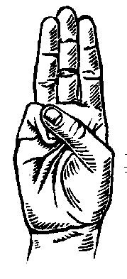**Grand Prize – Our top selling Scout will receive a $500 Gift Card!**

**Weekly drawings (June 6-July 25)**: Please fill out and submit the below “On my Honor” form each time a Scout sells 25 Camp Cards. Weekly drawings will take place during the sale. Winners will receive a gift card of $20. Scouts that sell 25 cards must submit their entry forms by **Friday NOON** of each week of the sale. Prizes will be awarded at the conclusion of the sale once unit accounts are settled and verified.

Please submit this form for the weekly drawings only to [326popcorn@scouting.org](mailto:326popcorn@scouting.org)

|  |  |
| --- | --- |
| “On my Honor”  I have sold 25 Camp Cards  (Please Print)  Scout’s Name:___________________________  Preferred contact information email or phone: _______________________________________  District:________________________________  Unit Type and Number:____________________ | “On my Honor”  I have sold 25 Camp Cards  (Please Print)  Scout’s Name:___________________________  Preferred contact information email or phone: _______________________________________  District:________________________________  Unit Type and Number:____________________ |

|  |  |
| --- | --- |
| “On my Honor”  I have sold 25 Camp Cards  (Please Print)  Scout’s Name:___________________________  Preferred contact information email or phone: _______________________________________  District:________________________________  Unit Type and Number:____________________ | “On my Honor”  I have sold 25 Camp Cards  (Please Print)  Scout’s Name:___________________________  Preferred contact information email or phone: _______________________________________  District:________________________________  Unit Type and Number:____________________ |