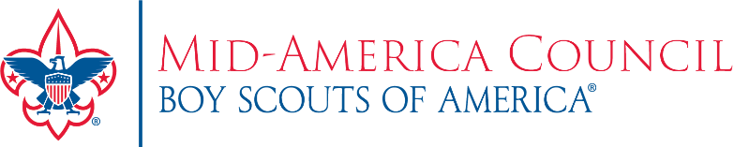
How to Use a Media Alert to Promote Your Fall Joining Event

A media alert can be another layer to help spread the word about your Unit’s Join Scouting event. The goal is to provide the ‘what,’ ‘when,’ and ‘where’ in a brief one-page document that can be sent to anyone that publishes public content in your area. Such as a newspaper, local shopper, community event page, radio or TV station, etc.

Below is a media alert template along with steps for creating and sending a media alert to promote your Join Scouting event.

- Complete the media contact information with the main point of contact for the event. This person should be easily accessible to answer any questions about the event and be present at the event to meet and work with any news media that might decide to attend.
- Update all the highlighted areas in the media template with your specific Unit and event information. Once entered, remove the highlighted boxes.
  - Be sure to include any unique information about your event. Is there a specific theme or planned activity?
- Once the media alert is complete, it’s ready to send off to your local news publications.
  - Research online or call the news outlets in your area to ask who best to send the media alert to.
  - If the news outlet has a public Facebook page, consider sending the alert to them through the private messaging feature.
  - OR if you (or another person in your Unit) has a connection that you have worked with in the past – send it to that specific contact.
- If you have any questions or need assistance, contact macmarketing@scouting.org.
- More marketing tools and resources for your fall joining event can be found here.

MEDIA ALERT

For Immediate Release Media Contact: Unit Contact Name
Cell Phone Number
E-mail Address

Local Youth Look to Grow into Their Full Potential
[Insert Community Name], [Insert Unit Name & Number] invites all youth ages [Insert age range of your Unit] to Join Scouting Event

WHAT: [Insert Information about your event] (Example: [Insert Unit Name] is inviting boys and girls grades K – 5th to join Cub Scouts at our fall joining event. We welcome all families to participate in Cub Scouts, a program renowned for character-building fun and adventure. In Scouting, youth grow into the best version of themselves through hands-on learning, service to community, STEM development, and a wide range of fun-filled activities.)

[Be sure to include any specific details about your event such as a planned activity.]

Learn more at Signup4Scouting.org.

WHEN: [Insert Date & Time of your event]

WHERE: [Insert location of your event]

Photo & Video Opportunities: Media outlets are welcome to capture both photos and video of Scouts and families at the fall joining event. Interviews with Unit representatives can also be arranged.

About the Mid-America Council
Since 1910, the Boy Scouts of America has instilled timeless values of character, citizenship and leadership in each young man and woman who has entered the Scouting program. The Mid-America Council continues this tradition through educational based skills and activities. For more information about the Mid-America Council, please visit: https://mac-bsa.org/
###

