CAMP CEDARS 2025
PROGRAM SIGN UP DETAILS

March 3 at 10:00 am CST for Scouts 14+
March 17 at 10:00 am CST for ALL Scouts
*Programs are first-come, first-serve

Complete before selecting programs:
- Pay $100 deposit per Scout.
- If any Scout qualifies for a discount, including selling Camp Cards, please indicate those for each Scout.
- Scouts applying for a Campership can receive a $50 credit towards the deposit.
- Review the Program Schedule and the prerequisites in the Program Guide with the Scout.
- Include age and rank for Scouts. There are minimum age requirements for the following classes:

  - Advanced COPE (13 years old)
  - ATV Safety Course (14 years old)
  - COPE (13 years old)
  - Cowboy Action Shoot (14 years old)
  - NRA First Step Pistol Program (14 years old)

How to enter programs:
- Log into your registration and click “Update Information” under each Scout name or youth spot.
- Click on “Select Classes” and more options will appear.
- Click on desired class to add to the schedule from the right. Programs are organized by class period and then alphabetically.

(Review images on the back side of this sheet for an example.)

Questions when registering for classes contact:
Brittany Jackowiak, Assistant Camp Director – lovetoclimb5@gmail.com
Natalie Andersen, Cedars Camp Director – Natalie.Andersen@scouting.org
Madi Carstens, MAC Camping Director at 402-514-3019 or madi.carstens@scouting.org
Member Services at 402-431-9272 or mac@scouting.org

How to Register for Programs:
- Click on youth name to expand information and then select “Update Information”.
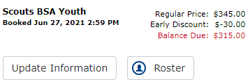The Roster button will load Scout information directly
- Click “Select Classes” and more options will become available.
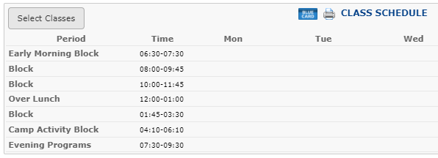
- Utilize the “Search …” bar to find a specific class. Click on the program to add it to the schedule. Programs are organized by class period and then alphabetically.
  - Period 1 = block A & D Period 2 = block B & E Period 3 = block C & F
  - Days of class are listed in the class details.
For the example below, Citizenship in the World is block D and Art is block A.
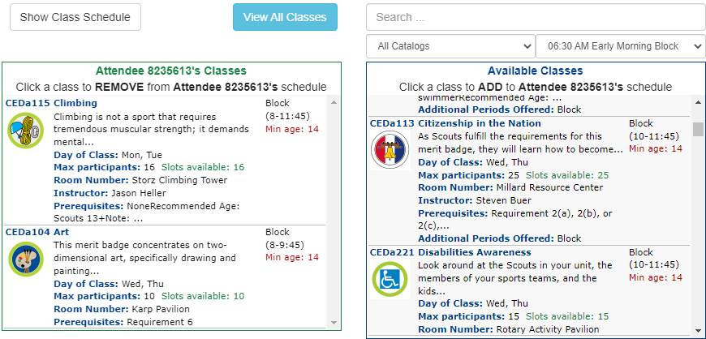

- Click on “Show Class Schedule” to view this format.
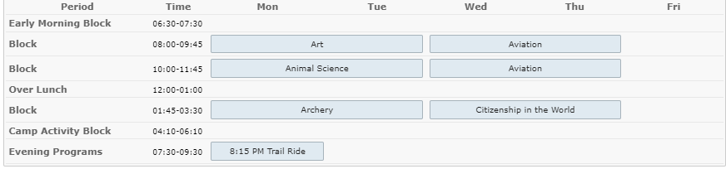
NOTE: Some additional programs outside of the blocks require sign-ups including evening merit badges. These programs are listed in the Class Catalog.

